**FITPARADE – IFBB PRO INSPECTION REPORT**

**Date:** October 19th, 2025

**Place:** Budapest, Dr. Koltai Jenő Sportközpont  
Address: 1123 Csörsz utca 2-8

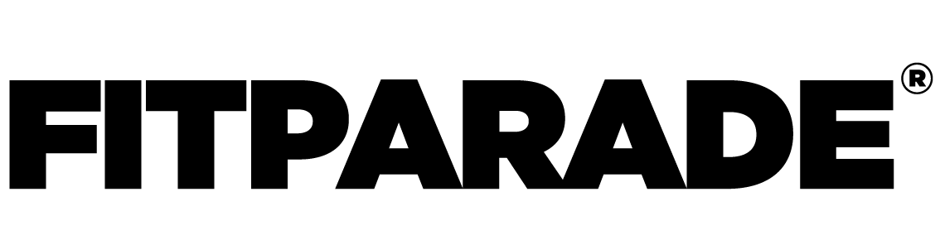**Athletes meeting** (For IFBB Pro competitors)  
Place: Budapest, Dr. Koltai Jenő Sportközpont  
Date: October 17th 17:00-18:00  
Address: 1123 Csörsz utca 2-8  
  
**IFBB PRO backstage ticket:** 150 EUR (valid for amateur and PRO shows as well)  
  
**Competitions:**  
- NPC Regional & Natural Regional– October 18th (NPC WORLDWIDE MEMBERSHIP required)  
- IFBB Pro Qualifier – October 19th (NPC WORLDWIDE MEMBERSHIP required)  
**- IFBB Pro Bikini – October 19th evening  
- IFBB Pro Classic Physique – October 19th evening**

**Official Tanning partner: PRO TAN EUROPE**

Tanning & make up & hair services

**FOR HUNGARIAN** **competitors**:

[**https://www.myshowtime.hu/versenybarnitas/event/504**](https://www.myshowtime.hu/versenybarnitas/event/504)

**FOR NON HUNGARIAN competitors:**

[**https://www.protan-europe.com/book-your-tan/836?l=**](https://www.protan-europe.com/book-your-tan/836?l=)

**DAY 1 – October 18th, Saturday:**

**- Blade Sport NPC Regional:**   
Categories: Women’s Fitness, Women’s Figure, Women’s Physique, Women’s Bodybuilding, Women’s Bikini, Women’s Fit Model, Women’s Wellness, Men’s Classic Physique, Men’s Bodybuilding, Men’s Physique   
 **- NPC Natural Regional:**   
Categories: Women’s Fitness, Women’s Figure, Women’s Physique, Women’s Bodybuilding, Women’s Bikini, Women’s Fit Model, Women’s Wellness, Men’s Classic Physique, Men’s Bodybuilding, Men’s Physique

**DAY 2 – October 19th, Sunday:**

**- IFBB Pro Qualifier:**   
Categories: Women’s Fitness, Women’s Figure, Women’s Physique, Women’s Bodybuilding, Women’s Bikini, Women’s Wellness, Men’s Classic Physique, Men’s Bodybuilding, Men’s Physique   
  
Competitors are allowed to enter at 06:00. The competition starts at 09:00.

**On the second day 10 IFBB Pro cards will be awarded.**

**The IFBB PRO SHOWS will start after the amateurs around 19.00  
  
-Irondiva Classic IFBB Pro Bikini**  
**-Eagle Classic IFBB Pro Classic Physique**

**Contact:**  
Email: [office@fitparade.hu](mailto:office@fitparade.hu); Phone: +36 70 380 6057